# 

# CHAPTER 1

# INTRODUCTION

## INTRODUCTION TO COMPUTERGRAPHICS

Computer Graphics is concerned with all aspects of producing pictures or images using a computer. Graphics provides one of the most natural means of communicating within a computer, since our highly developed 2D and 3D pattern-recognition abilities allow us to perceive and process pictorial data rapidly and effectively. Interactive computer graphics is the most important means of producing pictures since the invention of photography and television.

### Applications of Computer Graphics

* + 1. Display of information
    2. Design
    3. Simulation and animation
    4. User-interfaces

### The Graphics Architecture

Graphics Architecture can be made up of seven components:

1. Display processors
2. Pipeline architectures
3. The graphics pipeline
4. Vertex processing
5. Clipping and primitive assembly
6. Rasterization
7. Fragment processing



Memory

Frame buffer

Processor

Output Device

Input

Input

Mouse

Mouse

Input

Mouse

Device

Input

Mouse

### Figure 1.1: Components of Graphics Architecture and their working

Figure 1.1 shows the flow of information through components of a computer during execution of graphics application. The processor takes the input from all the supported input devices. It can access the memory to get additional information about the current frame and previously displayed frames. Using all the available input, the frame buffer is filled. The output device gets its instruction from frame buffer.

* 1. **INTRODUCTION TO OPENGL**

OpenGL is software used to implement computer graphics. The structure of OpenGL is similar to that of most modern APIs including Java 3D and DirectX. OpenGL is easy to learn, compared with other.

APIs are nevertheless powerful. It supports the simple 2D and 3D programs. It also supports the advanced rendering techniques. OpenGL API explains following 3 components

1. Graphics functions
2. Graphics pipeline and state machines
3. The OpenGL interfaces

There are so many polygon types in OpenGL like triangles, quadrilaterals, strips and fans. There are 2 control functions, which will explain OpenGL through,

1. Interaction with window system
2. Aspect ratio and viewports

**Frame Buffer**

**GL**

**OpenGL Application Program**

**GLUT**

**GLX**

**Xlib, Xtk**

### Figure 1.2: OpenGL Library organization

**OpenGL Application Program**

Most implementations of OpenGL have a similar order of operations, a series of processing stages called the OpenGL rendering pipeline. This ordering, as shown in Figure 1.2, is not a strict rule of how OpenGL is implemented but provides a reliable guide for predicting what OpenGL will do. The following diagram (fig 1.3) shows the assembly line approach, which OpenGL takes to process data. Geometric data (vertices, lines, and polygons) follow the path through the row of boxes that includes evaluators and per-vertex operations, while pixel data (pixels, images, and bitmaps) are treated differently for part of the process. Both types of data undergo the same final steps before the final pixel data is written into the framebuffer.

Pre-vertex operations and primitive assembly

Display list

Evaluators

Per-Fragment operation

Rasterization

Pixel operation

Texture

Assembly

**GLU**

Frame Buffer



Vertex data

Pixel data

### Figure 1.3: OpenGL Order of Operations

**CHAPTER 2**

**REQUIREMENTS SPECIFICATION**

**2.1 SOFTWAREREQUIREMENTS**

* + - Operating system – Windows10
    - Microsoft Visual Studio2017
    - OPENGL library files – GL, GLU, GLUT
    - Language used is C/C++

## 2.2 HARDWAREREQUIREMENTS

* + - Processor – Pentium Pro
    - Memory - 128MBRAM
    - 20 GB Hard Disk Drive
    - Mouse or another pointing device
    - Keyboard
    - Display device

**CHAPTER 3**

**SYSTEM DEFINITION**

## PROJECT DESCRIPTION

This project contains Ferris Wheel. When the user presses ‘c/C’ key, wheel will start rotating and vice-versa. The user can control the speed of rotation by pressing ‘v/V’ or ‘x/X’ keys from keyboard where ‘v/V’ increases the speed and ‘x/X’ decreases the speed. When the user press ‘w/W’,’s/S’, ’a/A’ & ’d/D’ key, it will rotate the whole wheel into Top, Bottom, Right and Left direction. These are showed in the System-Architecture.

The user can also increase and decrease the number of cabins by pressing key ‘+/1’ and ‘-/0’ respectively.

* 1. **BUILT-IN FUNCTIONS**
* **void glMatrixMode(GL_PROJECTION):** Applies subsequent matrix operations to the projection matrix stack.
* **void glutlnitDisplayMode( ):** It requests a display with the properties in mode.
* **void glutCreateWindow( )**: It creates a window on the display.
* **void glutMainloop( )**: It causes the program to enter an event processing loop.
* **void glutPostRedisplay( ):** It requests that the display callback be to be executed after the current callback returns.
* **void glutDisplayFunc( ):** It registers the display function that is executed when the window needs to be redrawn.
* **void glutKeyboardFunc( ):**  It registers the keyboard callback function.
* **void glEnable( )**: It enables an openGL feature.
* **void glFlush( )**:Forces any buffered openGL commands to execute.
* **void glClearColor( )**: It sets the present RGB clearing the color buffer.
* **void glBegin( )**: It initiates new primitive and vertices.
* **void glEnd( )**: It terminates a list of vertices.

## 3.3 USER DEFINED FUNCTIONS

* + - **void reshape(int w, int h):** The reshape function is a call-back function which is called to regain the size or shape of the application window.
    - **void draw_scene():** This function is used to draw the base structure for the Ferris wheel.
    - **void keyboard(unsigned char key, int x, int y):** This function contains the key function that is used to control the movements.
    - **float toRad(float deg):** This function is used to change the degree into radian.
    - **void init(void):** This function is used to initialize the components of the window created .
    - **void rotate():**This function is used to rotates the blades of fan.
    - **void idle():** This function is used for animation.
  1. **SYSTEM ARCHITECTURE**

It shows the simple work architecture of Ferris Wheel.

Value= inv_rot = !inv_rot;

If ‘W’

If ‘I’

If ‘C’

If ‘D’

If ‘A’

If ‘S’

Value= anim = !anim;

Value= roty -= 2.0

Value= roty += 2.0

Value= rotx -= 2.0

Value= rotx += 2.0

Main

Display

Keyboard

Keys

draw_scene()

init(void)

glutPostRedisplay()

**Fig 3.1 : System architecture of Ferris Wheel**

**CHAPTER 4**

**IMPLEMENTATION**

## 4.1 SOURCE CODE

#include <GL/glut.h>

#include <GL/glu.h>

#include <GL/gl.h>

#include <cmath>

#include<stdio.h>

#define M_PI 3.1414

#define WHEEL 1

#define CABIN 2

GLfloat global_ambient[] = { 0.3f,0.3f,0.3f,1.0f };

GLfloat dir_ambient[] = { 0.6f,0.6f,0.6f,1.0f };

GLfloat dir_diffuse[] = { 0.8f,0.8f,0.8f,1.0f };

GLfloat dir_specular[] = { 1.0f,1.0f,1.0f,1.0f };

GLfloat dir_position[] = { 0.0f,1.0f,1.0f,0.0f };

// Color Material - Specular

GLfloat mat_specular[] = { 0.6,0.6,0.6,1.0 };

GLfloat rotx = 0, roty = 0;

GLfloat c_radius, w_rot;

GLint n_bars = 16, w_speed = 0.25;

bool anim = false;

bool inv_rot = false;

float toRad(float deg)

{

return (deg*M_PI) / 180;

}

void init(void)

{

glLightModelfv(GL_LIGHT_MODEL_AMBIENT, global_ambient);

glLightfv(GL_LIGHT0, GL_AMBIENT, dir_ambient);

glLightfv(GL_LIGHT0, GL_DIFFUSE, dir_diffuse);

glLightfv(GL_LIGHT0, GL_SPECULAR, dir_specular);

glLightfv(GL_LIGHT0, GL_POSITION, dir_position);

glEnable(GL_LIGHT0);

glEnable(GL_COLOR_MATERIAL);

glColorMaterial(GL_FRONT, GL_AMBIENT_AND_DIFFUSE);

glMaterialfv(GL_FRONT, GL_SPECULAR, mat_specular);

glMateriali(GL_FRONT, GL_SHININESS, 30);

glEnable(GL_LIGHTING);

glEnable(GL_LIGHT0);

glEnable(GL_DEPTH_TEST);

glEnable(GL_NORMALIZE);

glShadeModel(GL_SMOOTH);

glNewList(WHEEL, GL_COMPILE);

glColor3f(0.5, 0, 0);

// Center front

glBegin(GL_TRIANGLE_FAN);

glVertex3f(0, 0, 15);

for (float angle = 0; angle <= 360; angle += 0.1)

{

glVertex3f(5 * cos(toRad(angle)), 5 * sin(toRad(angle)), 15);

}

glEnd();

// Center

glBegin(GL_QUAD_STRIP);

for (float angle = 0; angle <= 360; angle += 0.1) {

glVertex3f(5 * cos(toRad(angle)), 5 * sin(toRad(angle)), 15);

glVertex3f(5 * cos(toRad(angle)), 5 * sin(toRad(angle)), -15);

}

glEnd();

// Center back

glBegin(GL_TRIANGLE_FAN);

glVertex3f(0, 0, -15);

for (float angle = 0; angle <= 360; angle += 0.1) {

glVertex3f(5 * cos(toRad(angle)), 5 * sin(toRad(angle)), -15);

}

glEnd();

// Wheel structure front

for (float angle = 0; angle <= 360; angle += 0.1) {

glBegin(GL_POLYGON);

glVertex3f(30 * cos(toRad(angle)), 30 * sin(toRad(angle)), 4);

glVertex3f(28 * cos(toRad(angle)), 28 * sin(toRad(angle)), 4);

glVertex3f(28 * cos(toRad(angle + 0.2)), 28 * sin(toRad(angle + 0.2)), 4);

glVertex3f(30 * cos(toRad(angle + 0.2)), 30 * sin(toRad(angle + 0.2)), 4);

glEnd();

}

glBegin(GL_QUAD_STRIP);

for (float angle = 0; angle <= 360; angle += 0.1) {

glVertex3f(30 * cos(toRad(angle)), 30 * sin(toRad(angle)), 4);

glVertex3f(30 * cos(toRad(angle)), 30 * sin(toRad(angle)), 3.5);

}

glEnd();

glBegin(GL_QUAD_STRIP);

for (float angle = 0; angle <= 360; angle += 0.1) {

glVertex3f(28 * cos(toRad(angle)), 28 * sin(toRad(angle)), 4);

glVertex3f(28 * cos(toRad(angle)), 28 * sin(toRad(angle)), 3.5);

}

glEnd();

// Wheel structure front

for (float angle = 0; angle <= 360; angle += 0.1) {

glBegin(GL_POLYGON);

glVertex3f(30 * cos(toRad(angle)), 30 * sin(toRad(angle)), 3.5);

glVertex3f(28 * cos(toRad(angle)), 28 * sin(toRad(angle)), 3.5);

glVertex3f(28 * cos(toRad(angle + 0.2)), 28 * sin(toRad(angle + 0.2)), 3.5);

glVertex3f(30 * cos(toRad(angle + 0.2)), 30 * sin(toRad(angle + 0.2)), 3.5);

glEnd();

}

// Wheel structure back

for (float angle = 0; angle <= 360; angle += 0.1) {

glBegin(GL_POLYGON);

glVertex3f(30 * cos(toRad(angle)), 30 * sin(toRad(angle)), -4);

glVertex3f(28 * cos(toRad(angle)), 28 * sin(toRad(angle)), -4);

glVertex3f(28 * cos(toRad(angle + 0.2)), 28 * sin(toRad(angle + 0.2)), -4);

glVertex3f(30 * cos(toRad(angle + 0.2)), 30 * sin(toRad(angle + 0.2)), -4);

glEnd();

}

glBegin(GL_QUAD_STRIP);

for (float angle = 0; angle <= 360; angle += 0.1) {

glVertex3f(30 * cos(toRad(angle)), 30 * sin(toRad(angle)), -4);

glVertex3f(30 * cos(toRad(angle)), 30 * sin(toRad(angle)), -3.5);

}

glEnd();

glBegin(GL_QUAD_STRIP);

for (float angle = 0; angle <= 360; angle += 0.1) {

glVertex3f(28 * cos(toRad(angle)), 28 * sin(toRad(angle)), -4);

glVertex3f(28 * cos(toRad(angle)), 28 * sin(toRad(angle)), -3.5);

}

glEnd();

// Wheel structure back

for (float angle = 0; angle <= 360; angle += 0.1) {

glBegin(GL_POLYGON);

glVertex3f(30 * cos(toRad(angle)), 30 * sin(toRad(angle)), -3.5);

glVertex3f(28 * cos(toRad(angle)), 28 * sin(toRad(angle)), -3.5);

glVertex3f(28 * cos(toRad(angle + 0.2)), 28 * sin(toRad(angle + 0.2)), -3.5);

glVertex3f(30 * cos(toRad(angle + 0.2)), 30 * sin(toRad(angle + 0.2)), -3.5);

glEnd();

}

glEndList();

// CAbin

glNewList(CABIN, GL_COMPILE);

glColor3f(0.5, 0, 0);

// Bar

glBegin(GL_TRIANGLE_FAN);

glVertex3f(0, 0, -4);

for (float angle = 0; angle <= 360; angle += 0.1) {

glVertex3f(0.5*cos(toRad(angle)), 0.5*sin(toRad(angle)), -4);

}

glEnd();

glBegin(GL_QUAD_STRIP);

for (float angle = 0; angle <= 360; angle += 0.1) {

glVertex3f(0.5*cos(toRad(angle)), 0.5*sin(toRad(angle)), -3.5);

glVertex3f(0.5*cos(toRad(angle)), 0.5*sin(toRad(angle)), 3.5);

}

glEnd();

glBegin(GL_TRIANGLE_FAN);

glVertex3f(0, 0, 4);

for (float angle = 0; angle <= 360; angle += 0.1) {

glVertex3f(0.5*cos(toRad(angle)), 0.5*sin(toRad(angle)), 4);

}

glEnd();

// Cono

glPushMatrix();

glColor3f(0.95, 0.67, 0.06);

glTranslatef(0, -5, 0);

glRotatef(-90, 1, 0, 0);

glutSolidCone(2, 5, 50, 50);

glPopMatrix();

glEndList();

}

void draw_scene() {

glPushMatrix();

glColor3f(0.02, 0.22, 0.02);

glTranslatef(0, -40, 0);

glScalef(50, 2, 50);

glutSolidCube(2);

glPopMatrix();

glPushMatrix();

glCallList(WHEEL);

glPopMatrix();

glPushMatrix();

glRotatef(w_rot, 0, 0, 1);

for (int i = 0; i < n_bars; i++) {

c_radius = (360.0 / n_bars)*i;

glPushMatrix();

// Axis

glPushMatrix();

glColor3f(0.92, 0.12, 0.12);

glRotatef(c_radius, 0, 0, 1);

glRotatef(-11, 1, 0, 0);

glTranslatef(0, 14.5, 10);

glScalef(1, 28, 0.5);

glutSolidCube(1);

glPopMatrix();

glPushMatrix();

glColor3f(0.92, 0.12, 0.12);

glRotatef(c_radius, 0, 0, 1);

glRotatef(11, 1, 0, 0);

glTranslatef(0, 14.5, -10);

glScalef(1, 28, 0.5);

glutSolidCube(1);

glPopMatrix();

glTranslatef(28 * cos(toRad(c_radius)), 28 * sin(toRad(c_radius)), 0);

glRotatef(-w_rot, 0, 0, 1);

glCallList(CABIN);

glPopMatrix();

}

glPopMatrix();

glPushMatrix();

glColor3f(0.3, 0.3, 0.3);

glRotatef(-30, 0, 0, 1);

glTranslatef(0, -25, 12);

glScalef(3, 40, 2);

glutSolidCube(1);

glPopMatrix();

glPushMatrix();

glColor3f(0.3, 0.3, 0.3);

glRotatef(30, 0, 0, 1);

glTranslatef(0, -25, 12);

glScalef(3, 40, 2);

glutSolidCube(1);

glPopMatrix();

glPushMatrix();

glColor3f(0.3, 0.3, 0.3);

glRotatef(-30, 0, 0, 1);

glTranslatef(0, -25, -12);

glScalef(3, 40, 2);

glutSolidCube(1);

glPopMatrix();

glPushMatrix();

glColor3f(0.3, 0.3, 0.3);

glRotatef(30, 0, 0, 1);

glTranslatef(0, -25, -12);

glScalef(3, 40, 2);

glutSolidCube(1);

glPopMatrix();

glPushMatrix();

glTranslatef(20, -30, 30);

glColor3f(1, 0, 0);

glPushMatrix();

glRotatef(-90, 1, 0, 0);

glutSolidCone(2, 2, 50, 50);

glPopMatrix();

glColor3f(1, 0.5, 0.5);

glutSolidSphere(1, 50, 50);

glPushMatrix();

glTranslatef(0, -2, 0);

glScalef(0.5, 4, 0.5);

glutSolidCube(1);

glPopMatrix();

glPushMatrix();

glTranslatef(-0.9, -6, 0);

glRotatef(-20, 0, 0, 1);

glScalef(0.5, 5, 0.5);

glutSolidCube(1);

glPopMatrix();

glPushMatrix();

glTranslatef(0.9, -6, 0);

glRotatef(20, 0, 0, 1);

glScalef(0.5, 5, 0.5);

glutSolidCube(1);

glPopMatrix();

glPushMatrix();

glTranslatef(-0.9, -2, 0);

glRotatef(-120, 0, 0, 1);

glScalef(0.5, 2, 0.5);

glutSolidCube(1);

glPopMatrix();

glPushMatrix();

glTranslatef(0.9, -2, 0);

glRotatef(120, 0, 0, 1);

glScalef(0.5, 2, 0.5);

glutSolidCube(1);

glPopMatrix();

glPopMatrix();

}

void display(void) {

glClear(GL_COLOR_BUFFER_BIT | GL_DEPTH_BUFFER_BIT);

glClearColor(0.64, 0.77, 1, 1);

glPushMatrix();

glTranslatef(0, 0, -100);

glRotatef(rotx, 1, 0, 0);

glRotatef(roty, 0, 1, 0);

draw_scene();

glPopMatrix();

glutSwapBuffers();

}

void idle() {

if (anim) {

if (inv_rot)

w_rot -= w_speed;

else

w_rot += w_speed;

glutPostRedisplay();

}

}

void reshape(int w, int h) {

// Prevent a divide by zero

if (h == 0)

h = 1;

// Set Viewport to window dimensions

glViewport(0, 0, w, h);

// Calculate aspect ratio of the window

float fAspect = (GLfloat)w / (GLfloat)h;

// Set the perspective coordinate system

glMatrixMode(GL_PROJECTION);

glLoadIdentity();

gluPerspective(65.0, (GLfloat)w / (GLfloat)h, 1.0, 800.0);

glMatrixMode(GL_MODELVIEW);

glLoadIdentity();

}

void keyboard(unsigned char key, int x, int y) {

switch (key) {

case 'w':

case 'W':

rotx += 2.0;

break;

case 's':

case 'S':

rotx -= 2.0;

break;

case 'a':

case 'A':

roty += 2.0;

break;

case 'd':

case 'D':

roty -= 2.0;

break;

case '+':

case '1':

if (n_bars < 24)

n_bars++;

break;

case '-':

case '0':

if (n_bars > 8)

n_bars--;

break;

case 'x':

case 'X':

w_speed = w_speed - 0.05;

break;

case 'v':

case 'V':

w_speed = w_speed + 0.05;

break;

case 'c':

case 'C':

anim = !anim;

break;

case 'i':

case 'I':

inv_rot = !inv_rot;

}

glutPostRedisplay();

}

int main(int argc, char** argv) {

printf("\n****************************************************\n");

printf("\n------------------------VTU PROJECT-----------------------\n");

printf("\n----------------Mr. ASHUTOSH RANJAN-----------------\n");

printf("\n----------------------USN 1GA16CS033---------------------\n");

printf("\n****************************************************\n\n");

printf("\n--------------FERRIS WHEEL Mini Project---------------\n");

printf("\n---------------------VIth SEM (15CSL68) ---------------------\n");

printf("\n---Department of Computer Science and Engineering---\n\n");

printf("\n--------------Global Academy of Technology--------------\n\n");

printf("\n****************************************************\n\n\n");

printf("\n Top Movement :w or W\n");

printf("\n Bottom Movement :s or S\n");

printf("\n Rotate Right :a or A\n");

printf("\n Rotate Left :d or D\n");

printf("\n Wheel Rotation :c or C\n");

printf("\n Clockwise & Anti-clockwise :i or I\n");

printf("\n Wheel Rotation :c or C\n");

printf("\n Increase Speed :v or V\n");

printf("\n Decrease Speed :x or X\n");

printf("\n Increase No. of Cabin :+ or 1\n");

printf("\n Decrease No. of Cabin :- or 0\n");

glutInit(&argc, argv);

glutInitDisplayMode(GLUT_SINGLE | GLUT_RGB | GLUT_DEPTH);

glutInitWindowSize(1000, 700);

glutInitWindowPosition(500, 100);

glutCreateWindow("FERRIS WHEEL");

init();

glutReshapeFunc(reshape);

glutIdleFunc(idle);

glutDisplayFunc(display);

glutKeyboardFunc(keyboard);

glutMainLoop();

return 0;

}

# 

# CHAPTER 5

**TESTING AND RESULTS**

Testing is the process of evaluating a system or its component(s) with the intent to find whether it satisfies the specified requirements or not. Testing is executing a system in order to identify any gaps, errors, or missing requirements in contrary to the actual requirements.

* 1. **TESTING PROCESS**

Testing is an integral part of software development. Testing process certifies whether the product that is developed compiles with the standards that it was designed to. Testing process involves building of test cases against which the product has to be tested.

* 1. **TESTING OBJECTIVES**

The main objectives of testing process are as follows.

* Testing is a process of executing a program with the intent of finding an error.
* A good test case is one that has high probability of finding undiscovered error.
* A successful test is one that uncovers the undiscovered error.
  1. **DIFFERENT TYPES OF TESTING**

### Unit Testing

Individual components are tested to ensure that they operate correctly. Each component is tested independently, without other system components.

### Module Testing

A module is a collection of dependent components such as an object class, an abstract Data type or some looser collection of procedures and functions. A module related Components, so can be tested without other system modules.

### System Testing

This is concerned with finding errors that result from unanticipated interaction between Sub-system interface problems.

### Acceptance Testing

The system is tested with data supplied by the system customer rather than simulated testdata.

* 1. **TEST CASES**

The test cases provided here tests the most important features of this project.

**5.4.1 Test cases for the project**

|  |  |  |  |
| --- | --- | --- | --- |
| **Input** | **Expected Result** | **Observed Result** | **Remark** |
| Press ‘w/W’ from keyboard | Vertically Upward Movement | Wheel moved in upward direction | Pass |
| Press ‘s/S’ from keyboard | Vertically Downward Movement | Wheel moved in downward direction | Pass |
| Press ‘a/A’ from keyboard | Right-Hand Side Movement | Wheel moved along right-hand side | Pass |
| Press ‘d/D’ from keyboard | Left-Hand Side Movement | Wheel moved along left-hand side | Pass |
| Press ‘c/C’ from keyboard | Rotation of Ferris Wheel and Vice-versa | Wheel started rotating and vice-versa | Pass |
| Press ‘x/X’ from keyboard | Gradually Increase Speed of Wheel | Speed of Wheel increased gradually | Pass |
| Press ‘v/V’ from keyboard | Gradually Decrease Speed of Wheel | Speed of Wheel decreased gradually | Pass |
| Press ‘i/I’ from keyboard | Rotation of Wheel in Clockwise and Anti Clockwise Direction | Wheel rotated in clockwise and anti-clockwise direction | Pass |
| Press ‘+/1’ from keyboard | It’ll Increase No. of Cabins | No. of Cabins increased by 1 each time | Pass |
| Press ‘-/0’ from keyboard | It’ll Decrease No. of Cabins | No. of Cabins decreased by 1 each time | Pass |

**Fig 5.1: Test Cases for the project**

# 

# CHAPTER 6

# SNAPSHOTS

Snapshot 6.1 shows the Console window, which contains all the information and control keys. Whenever user execute this code, this console window will pop up with these outputs.

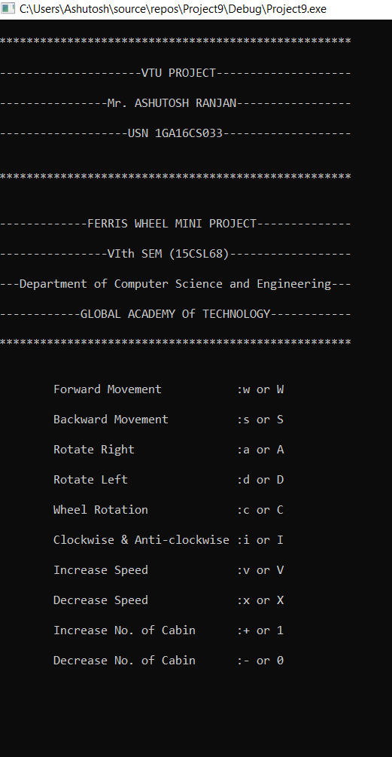

**Figure 6.1: Console Window**

Snapshot 6.2 shows the front view of rotating Ferris Wheel. This can be obtained by either pressing ‘c’ or ‘C’ from keyboard.

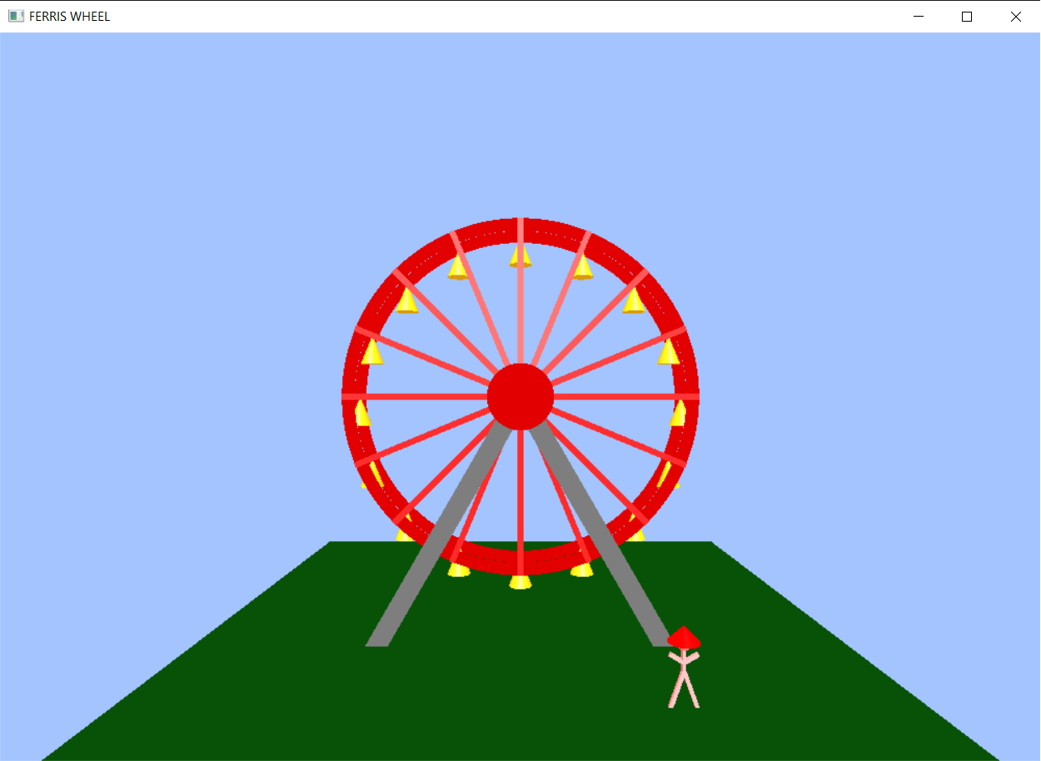

**Figure 6.2: Ferris wheel front view**

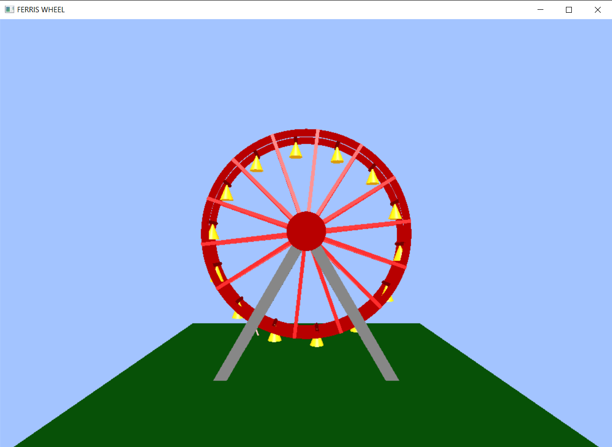Snapshot 6.3 shows the back view of the Ferris Wheel while rotation. This can be obtained by either pressing ‘a/A’ or ‘d/D’ from keyboard.

**Figure 6.3: Ferris wheel back view**

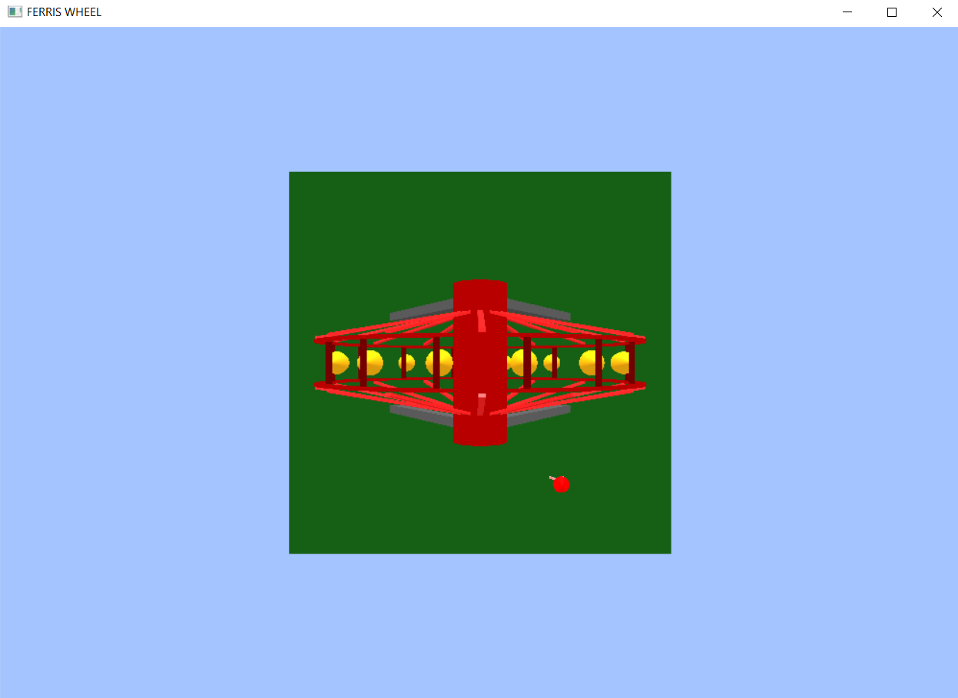Snapshot 6.4 shows the top view of the Ferris Wheel while rotation. This can be obtained by either pressing ‘w/W’ or ‘s/S’ from keyboard.

**Figure 6.4: Ferris Wheel top view**

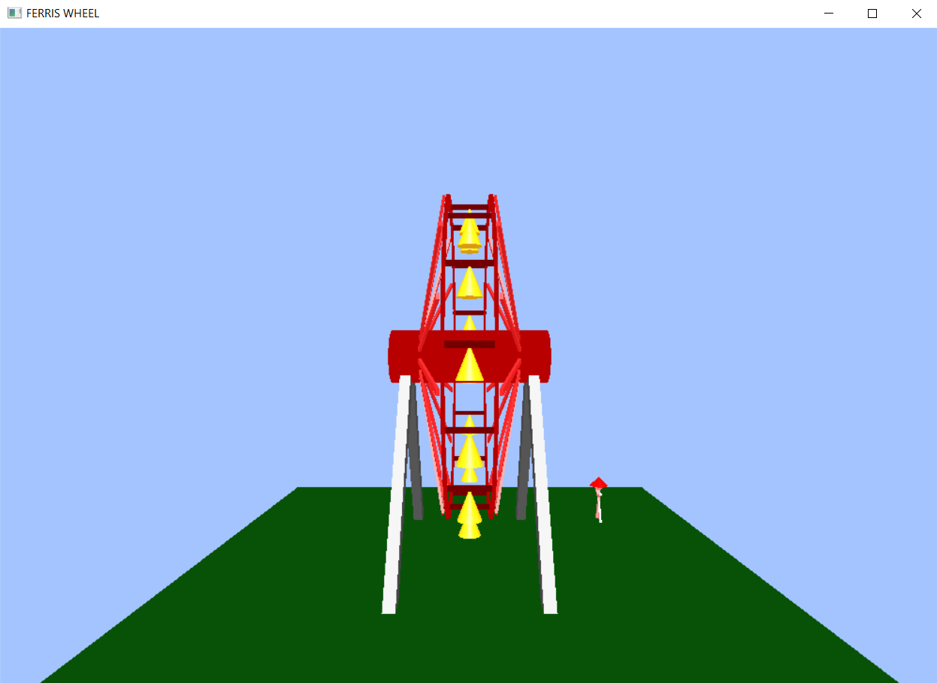Snapshot 6.5 shows the side view of the Ferris Wheel while rotation. This can be obtained by either pressing ‘a/A’ or ‘d/D’ from keyboard.

**Figure 6.5: Ferris Wheel side view**

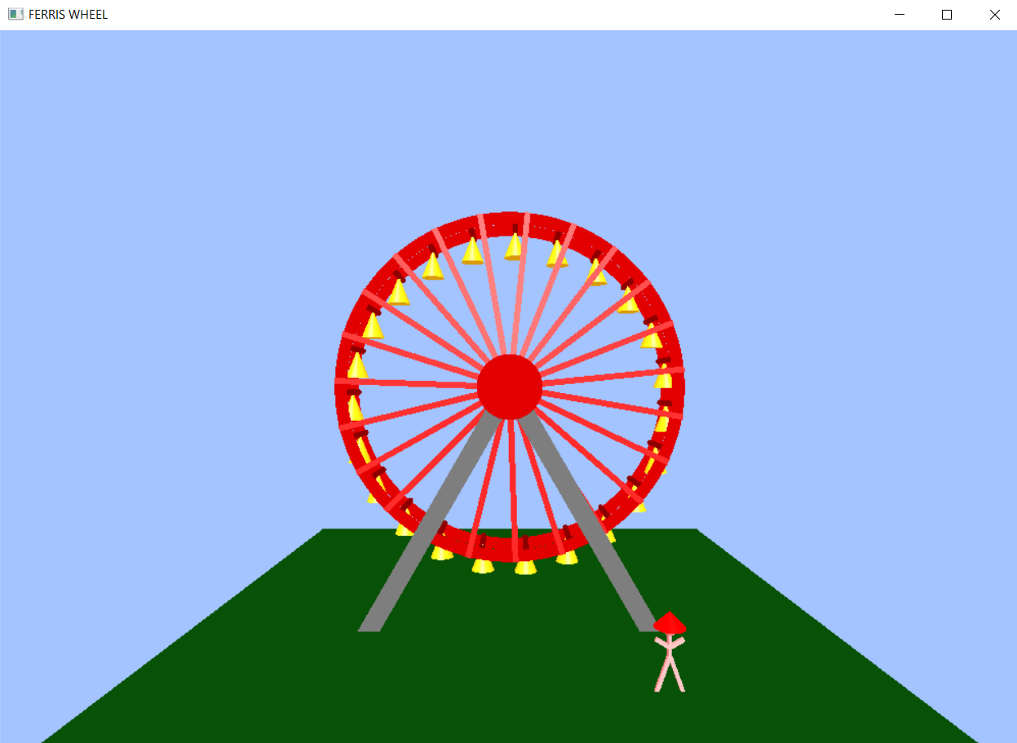 Snapshot 6.6 shows the Ferris Wheel with maximum number of cabins in it. This can be obtained by either pressing ‘+’ or ‘1’ from keyboard.

**Figure 6.6: Ferris Wheel with maximum number of Cabins**

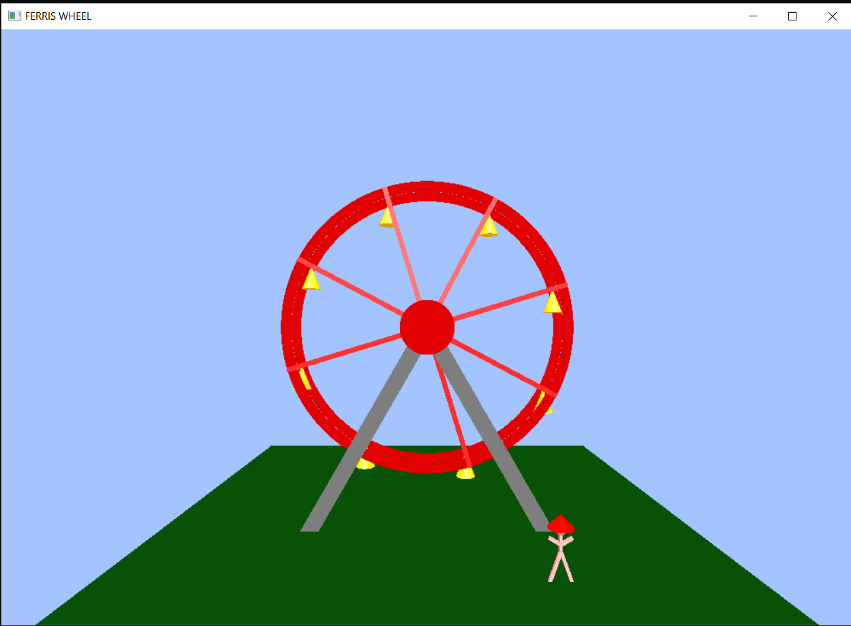Snapshot 6.7 shows the Ferris Wheel with minimum number of cabins in it. This can be obtained by either pressing ‘-’ or ‘0’ from keyboard.

**Figure 6.7: Ferris Wheel with lowest number of Cabins**

**CONCLUSION**

Using OpenGL functions and user defined functions a basic Ferris Wheel simulation is being done which is runs at different speed and no. of cabins can also be change. This is basic graphic animation made using only some built-in function and APIs. There are many functions and APIs available in OpenGL that makes animation effective and realistic.

The user-friendly interface allows the user to interact with it very effectively. So, I conclude on note that this project has given me a great exposure to the OpenGL and computer graphics. This is very reliable graphics package supporting various primitive objects like polygon, line loops, ambient light, triangle fan, quad strip etc. Also, this project is designed in such a way that one can view it from any directions using keyboard keys. Transformations like translation, rotation is also provided.

## BIBLIOGRAPHY

1. Donald D. Hearn, Pauline Baker, Warren Carithers: Computer Graphics with OpenGL, 4th Edition, Pearson Education.
2. Edward Angel: Interactive Computer Graphics A Top-Down Approach with OpenGL, 5th Edition, Pearson Education, 2008
3. [www.opengl.org](http://www.opengl.org)
4. [www.khronos.org](http://www.khronos.org)
5. www.github.com